Sustainability Initiatives & Success

Sustainable approaches:
The economy of Bangladesh, like most of the developing countries, is still predominantly agriculture based for any sort of sustainable development to take place, the farmer base is critically important. British American Tobacco Bangladesh maintains a unique relationship with more than 32,000 tobacco farmers in Bangladesh. Our relationship with these farmers enables us to be very proactive in helping them to address various economic, social, and environmental issues associated with their lives and livelihood.

Environmental Approach
GMO Free Tobacco production: annual confirmation of GMO free tobacco production is confirmed through analysis of seed & tobacco leaf from accredited laboratory. Till now all tobacco produced by BATB is free of GMO.

Afforestation: BAT Bangladesh started afforestation programme when we joined hands with the Bangladesh Forest Department in 1980 to conserve the forests and combat the negative impacts of climate change. So far, BAT Bangladesh has contributed around 87.5 million saplings free of cost to the country’s afforestation initiative in the last 35 years. In 2016, we are planning to distribute another 40 lakh saplings throughout Bangladesh. This is the largest private sector afforestation initiative in the country. Our endeavours have received several awards both at the National and Local Government levels. Such afforestation projects can be found in Chittagong, Bandarban, Cox’s Bazar, Khagrachari, Rangamati, Kushtia, Jhenaidah, Meherpur, Chuadanga, Magura, Rangpur, Lalmonirhat, Kurigram, Tangail, Manikganj, Rajbari, Dhaka and surrounding districts of Dhaka. The mentioned above locations are our Tobacco Growing area.

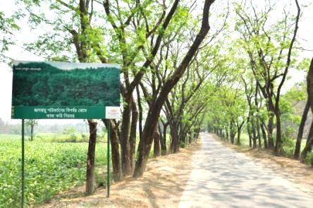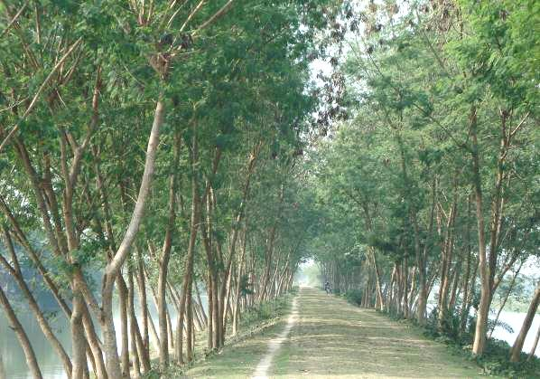
Strip & Embankment Plantation in Chittagong & Kushtia
Alternate Fuel: Since 1980 BAT Bangladesh is exploring the alternate source of wood fuel needed to cured tobacco in Bangladesh. Over the period, we have successfully replaced almost 100% of Flue Cured Virginia (FCV) curing at Kushtia by alternates like paddy straw, Jute stick, dhaincha sticks, sugarcane bagasse, tobacco stalk, maize stalk, rice husk, other crop residues etc., where It is important to mention that 70% of FCV tobacco in Bangladesh is grown at Kushtia.

About 30% of FCV is grown in Chittagong, Cox’s Bazar and Chittagong Hill Tracts. Through our concerted effort and with the growing interest of the farming community, alternate fuel is increasingly becoming popular in Chittagong leaf growing region as well. At present, alternate sources (dhaincha sticks, rice husk briquettes, other crop residues, etc.) are being used as wood fuel substitute. To meet the demand for wood fuel, every year we distribute 25 lac saplings free of cost in Chittagong to organize forestry of different kinds like Farmer’s own Forest, Community Forest, Participatory Forest and Forest belongs to the interested party as commercial.
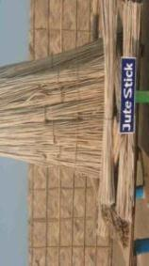
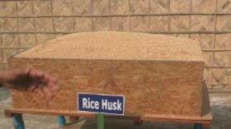
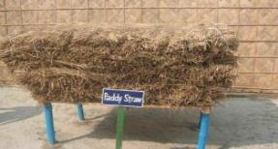
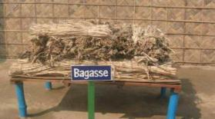
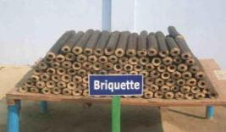
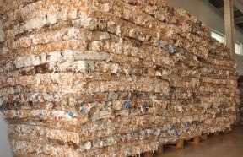
Paper briquette

Different Alternate Fuel Approaches
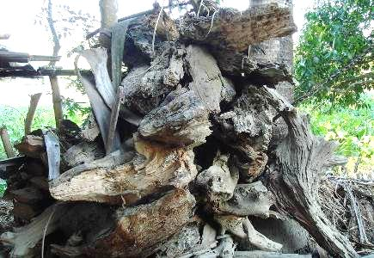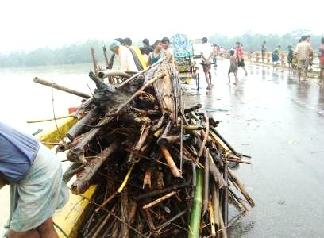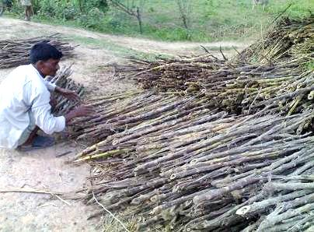
Rotten Floating wood Collection of floating wood Tobacco stalk
Biodiversity Corners & Farmers Training on Biodiversity: We acknowledge that we have both an impact and dependence on biodiversity, through our business operations and use of ecosystem services, such as forest products, soil and water. For this, we have established 64 biodiversity corners with the help of our registered farmers in order to acknowledge our farming communities about the importance of different elements in nature and their contribution in the ecosystem. It exhibits rare, endangered species and their inputs for conserving nature. Our plan is to set up 11 biodiversity centres in different growing locations every year. Our biodiversity corners are located in Kushtia, Meherpur, Chuadanga, Jhenaidah, Rangpur, Manikganj, Bandarban, Khagrachari and Cox’s Bazar districts which are our Growing location.
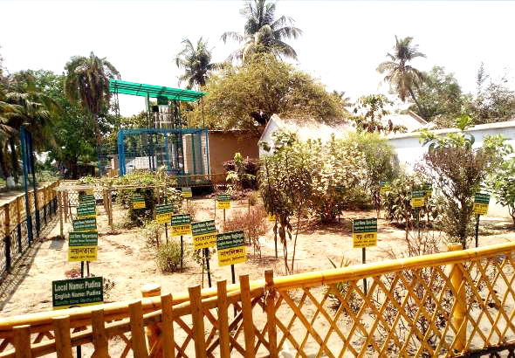
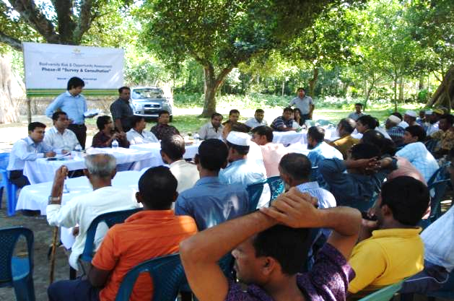
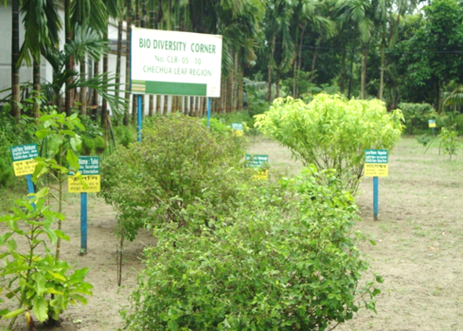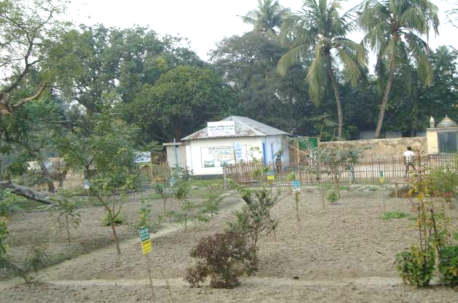
IPM, FFS & PPE: BAT Bangladesh established the first Integrated Pest Management (IPM) Club in 2005 to support the farmers for better crop management in Chechua Leaf Area, Kushtia. For last couple of years BAT Bangladesh has established a number of IPM clubs at its different Leaf growing locations with an aim to drive farmers’ education/ awareness regarding the non-chemical alternatives to pest management & safe use of Agrochemicals. The objective of IPM clubs is to reinforce government initiatives to reduce use of agrochemicals. One of our main focuses was to promote the usage of Neem Leaf Decoction (NLD). For this, we ensured installation of Neem Leaf Decoction Machines in our IPM clubs. The IPM club is led by a committee comprising of BATB representatives and local leading tobacco farmers. We provide our crop related training and briefing to the farmers in the IPM clubs. Use of bio fungicide e.g. Trichoderma in the seed bed, spraying neem leaf decoction both in seed bed and main field, bird perching, yellow sticky board, Trichogramma, pheromone trap are the most common IPM approaches to reduce the agrochemical usage.
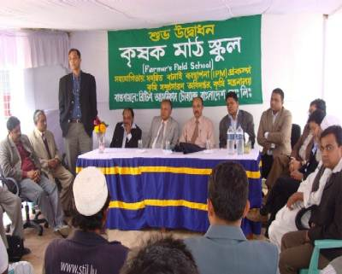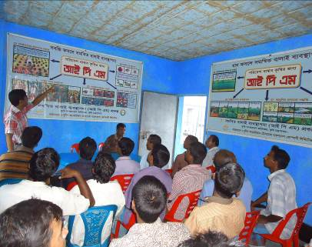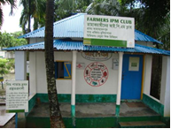
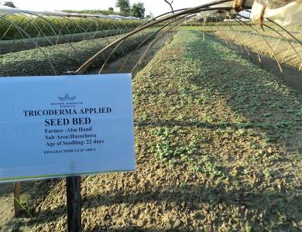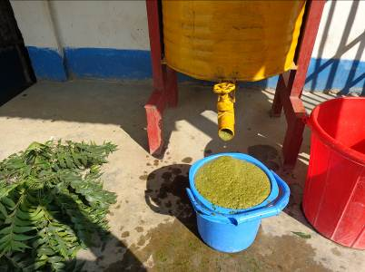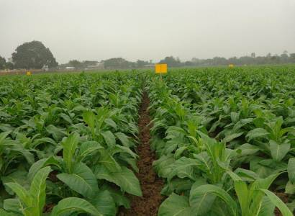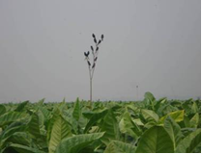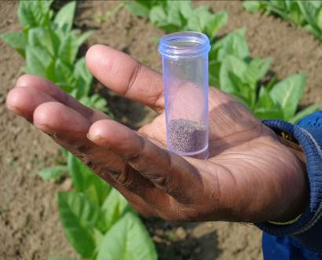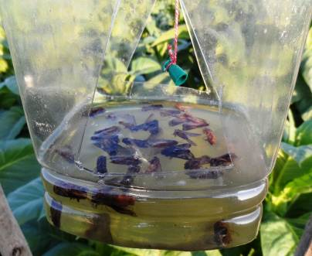
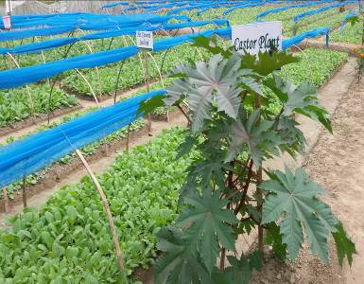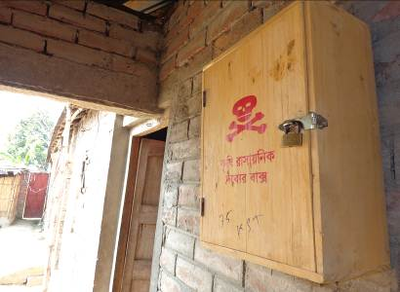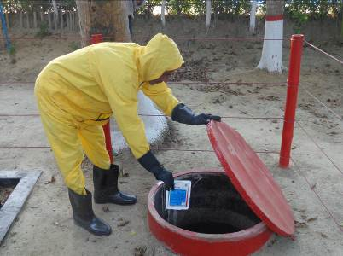
To embed the concept of IPM among the farmers, BATB has been running Farmers Field School (FFS) in partnership with Department of Agricultural Extension (DAE) under the Ministry of Agriculture. The FFS approach to drive IPM has made the IPM clubs as a power house for disseminating knowledge on pest management through non-chemical alternatives. This is a field orientated and participatory programme placing emphasis on learning by doing. Training takes place over an extended period and is a combination of classroom and field work. Moreover, IPM clubs are now contributing to create trained resources for IPM education and training. At present, we have 70 IPM clubs and have organised 64 FFS sessions. This initiative is to make sure that agro-chemicals are applied only when is assessed to be a must and with all necessary precautions. Formal trainings to farmers are ensured as per training calendar. To-date we have distributed 6,510 PPE set (one set PPE is shared by 6 farmers) & 5,000 agrochemical boxes for safe storage of agrochemicals. Our plan is to build 11 IPM clubs, organize 11 FFS Sessions and to distribute 1,000 sets of PPE’s and 1,000 nos. of Agrochemical Box to our registered farmers at free of cost every year.
Soil Fertility: Improving Soil Health
Green Manuring with Dhaincha: Bangladesh has low OM (organic matter) content in soil predominantly due to very high crop intensity (around 180%). BAT Bangladesh has introduced couple of initiatives among its farmers with a view to reduce need for chemical fertilizers & essentially to replenish the nitrogen content & organic matter level in the soil. In that, Green Manuring with ‘Dhaincha’ (Sesbania sp.) cultivation is one of the most effective bio-friendly approaches. Dhaincha fixes atmospheric nitrogen through its root nodules and hence when it is ploughed back to the soil, the nitrogen as well as organic matter content of the soil is increased. Through strong motivational activities, distribution of free seeds, demonstrating the cultivation processes & educating on its benefits, BATB has been able to successfully manage introducing this initiative among its farmers since 2000. In 2015 (April-May), we supplied 247 metric tons dhaincha seeds and ensured coverage of 85% registered farmers. Till now we have distributed 2,080 MT of dhaincha seeds among our registered farmers.
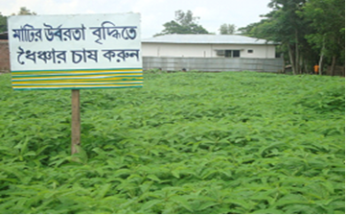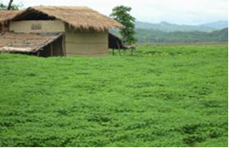
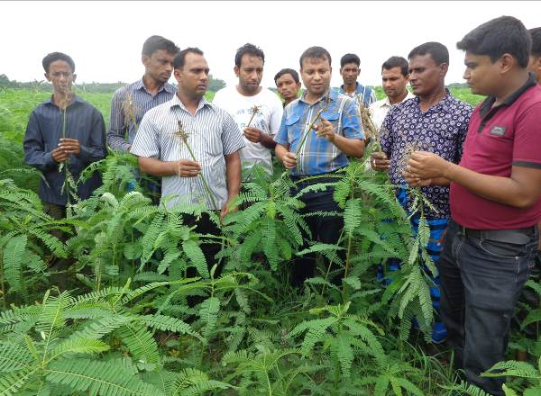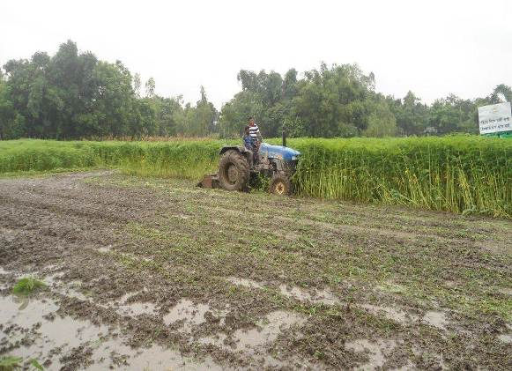

Compost Pit: As a part of bio-friendly agricultural practices, we provide the know-how & training to install compost pits in the homesteads of the tobacco farmers. This significantly reduces dependency on the use of chemical fertilizers for agricultural productions and also decreases the cost of production.

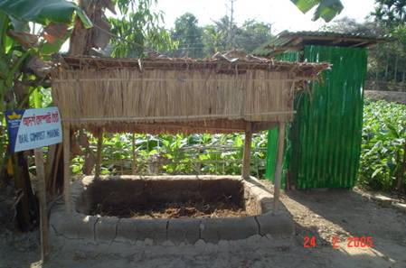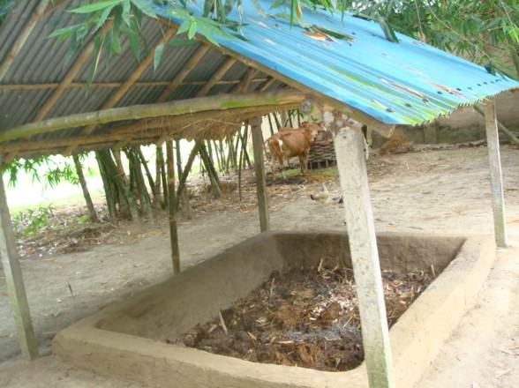
HYV (High Yielding Variety): In support of vertical growth instead of horizontal: To support tobacco growing sustainability, Leaf Supply Chain of BAT Bangladesh has been aggressively driving hybrid commercialization since 2012. Within only four years, BAT Bangladesh has increased FCV (Flue Cured Virginia) hybrid volume to 40%, which helped to decrease land usage by 18% to produce & meet semi-flavor & flavor style tobacco leaf requirement of BATB. In last four years, by using Hybrid varieties, BATB farmers have released 3,425 hectare of land. Hybrid tobacco varieties produce 20%-25% more yield compare to conventional varieties, which helped to commercialize its usage among the farmers.
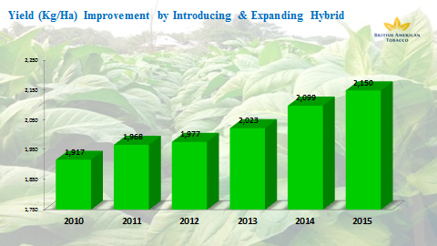

Control Irrigation Management
Tube Irrigation
We have introduced irrigation with recycled poly tube to reduce the water consumption needed for tobacco cultivation and to conserve this important natural resource. This ensures that only the required level of water is used and there is no wastage (percolation, leaching, runoff etc.) while carrying irrigation water from source to the target field.
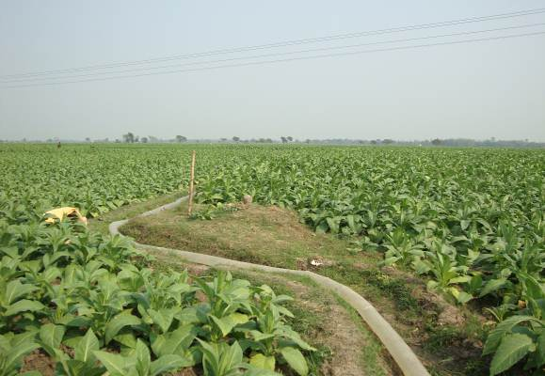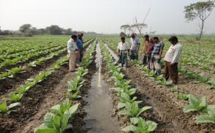

AWD (Alternate Wet and Dry) Irrigation Method for Rice Cultivation
For Rice cultivation we are motivating farmers irrigation based on water requirement is called AWD irrigation technique. In this technique using one perforated plastic or bamboo pipe and observe the water level of the rice field and then provide irrigation. The main objectives of AWD bio-friendly technique in rice field to conserve water & fuel and reduce irrigation cost.
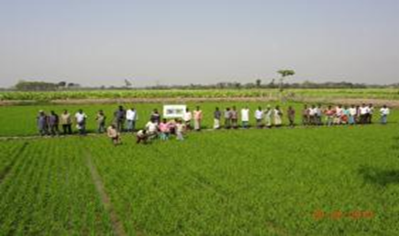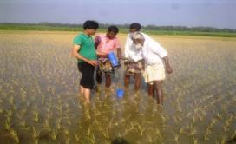

Corporate Social Responsibility
Probaho (Safe Drinking Water Project): BAT Bangladesh’s one of the initiatives is to provide people with safe drinking water in arsenic prone areas, prompting the Company to launch PROBAHO.

As a part of PROBAHO, the safe drinking water initiative, BAT Bangladesh has already installed 66 filtration plants to make water free from arsenic and other harmful contents. The PROBAHO plants are located in Jhenaidah, Chuadanga, Meherpur, Kushtia, Tangail, Manikganj, Satkhira, Gopalganj, Lalmonirhat, Kurigram, Jamalpur, Madaripur and Natore districts.

All the 66 plants now purify 336,204 litres of drinking water, meeting the need for 168,102 people per day. The plants are maintained by local committees consisting of members from local community.

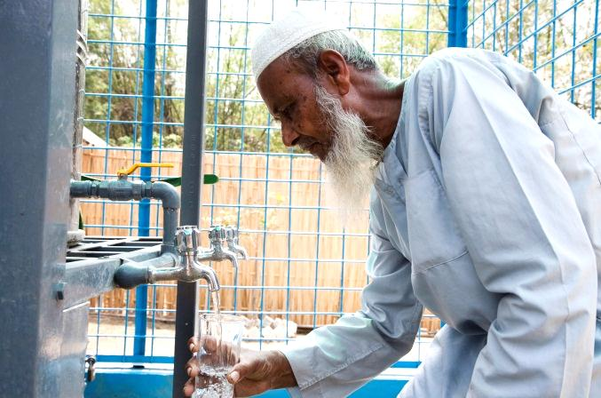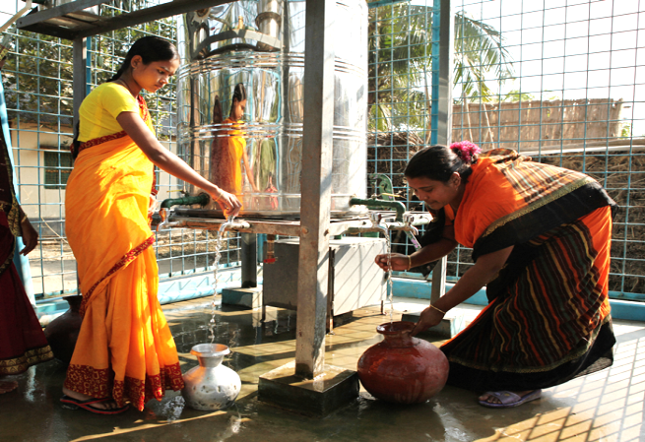

Deepto (Solar Home System for Chittagong Hill Tracts Communities): BAT Bangladesh’s new CSR initiative “Deepto” is providing Solar Home Systems (3-LED Lights and 1-Mobile Charging Point) in remote rural communities. The Company is installing the systems free of cost in under privileged areas of the country which are currently out of electricity.

So far, the Company has installed 1,801 units of solar house systems in 16 villages of Bandarban and Khagrachari districts using IDCOL approved solar panels, batteries and others accessories.

